**Task A**

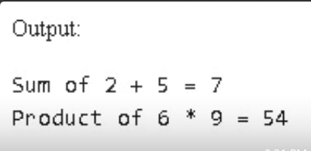

**Task B**

